适配器模式应用实践- 电源插座升级

（一）基本信息
本项目是课程单元项目（五级项目）。对实际应用问题进行分析，应用适配器模式解决该问题。学生可自选项目，应用设计模式进行设计并实现。
1、类型：
□ 综合类 ■ 设计类 □ 创新类 □ 验证类
2、学时安排：
课上1学时。
3、教学目标：
（1）理解适配器模式的应用场景、类图；
（2）分析给定问题，运用适配器模式来设计类图，并运用Java语言编程实现。

（二）组织形式
课上实施，每名学生单独完成项目的分析、设计与实现。

（三）任务描述
项目需求描述：
用户已经有一个两相插座（ TwoElectricOutlet ），新买一个三相插座（ ThreeElectricOutlet ），洗衣机（WashingMachine）使用三相插座，电视机（TV）用两相插座。
现在用户想用新买的三相插座来使用电视机和洗衣机 。
该如何做？
请完成以下任务：
（1）分析上述需求，应用设计模式，给出实现该项目的对象设计（类图）；
（2）依照类图，用Java语言实现，并进行测试。

（四）指导内容
1、相关知识：
（1）适配器模式的使用场景
将一个类的接口转换成客户希望的另外一个接口。Adapter模式使得原本由于接口不兼容而不能一起工作的那些类可以在一起工作。
在GoF的设计模式中，对适配器模式讲了两种类型，类适配器模式和对象适配器模式。由于类适配器模式通过多重继承对一个接口与另一个接口进行匹配，而C#、java等语言都不支持多重继承，因而对象适配器模式更加实用。
（2）适配器模式的通用类图
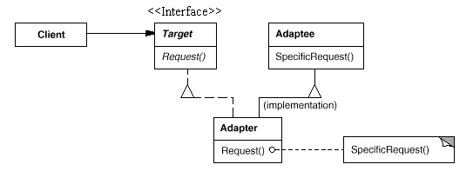
图1 类的Adapter模式结构图
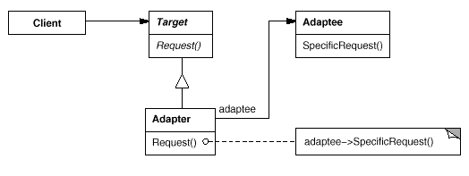
图2 对象的Adapter模式结构图

（3）其他知识资源：
http://www.uml.org.cn/sjms/201409171.asp
2、过程与步骤：
第一步：分析项目需求，识别出业务对象。
第二步：在领会适配器模式定义、通用类图的基础上，结合本项目的业务对象，设计出本项目的类图。
第三步：在Eclippse环境中新建一个Java工程，在类图与代码的映射规则的指引下，使用Java语言编写代码实现类图中的类。
第四步：编写测试驱动类，调试、运行程序。检查显示结果是否正确。

（五）成果提交
（1）完成类图设计与代码实现。
（2）随堂检查完成情况，成果物不需提交。

（六）考核方式与标准
1、考核方法
（1）评阅项目报告和程序；
（2）课堂抽查部分同学代码、运行结果。
2、考核标准
本项目占形成性考核成绩中的2分。
标准：能在策略模式通用类图的基础上，针对本项目的需求，完成类图的设计。根据类图，使用Java语言编写程序。
（1）类图完全正确，通过编译且运行结果正确，给2分；
（2）只给出通用类图或类图有部分错误，代码基本正确，给1分。

Application Practice of Adapter Mode-Upgrade of Power Socket
(1) Basic information
This project is a curriculum unit project (Level 5 project). The practical application problem is analyzed and the adapter mode is applied to solve the problem. Students can choose their own projects and apply design patterns to design and implement them.
1Teaching objectives:
(1) Understanding the application scenarios and class diagrams of the adapter pattern;
(2) Analyzing the given problems, using adapter pattern to design class diagram, and using Java language programming to achieve.
(2) Organizational form
In class, each student completes the analysis, design and implementation of the project independently.
(3) Task description
Project requirements description:
Users already have a two-phase electrical outlet, a new three-phase electrical outlet, a washing machine with three-phase outlet and a TV with two-phase outlet.
Now users want to use the newly purchased three-phase socket to use the TV and washing machine.
What should we do?
Please complete the following tasks:
(1) Analyzing the above requirements, applying the design pattern, giving the object design (class diagram) to realize the project;
(2) According to class diagram, it is implemented in Java language and tested.
(4) Guidance Contents
1. Relevant knowledge:
(1) Use scenarios of adapter patterns
Convert the interface of a class into another interface that the customer wants. Adapter mode enables classes that could not work together due to incompatibility of interfaces to work together.
In the design pattern of GoF, there are two types of adapter patterns: class adapter pattern and object adapter pattern. Because the class adapter pattern matches one interface with another through multiple inheritance, and C#, Java and other languages do not support multiple inheritance, the object adapter pattern is more practical.
(2) General class diagram of adapter pattern
Figure 1. Adapter schema structure diagram of class 1
The Adapter schema structure of the object in Figure 2
(3) Other knowledge resources:
Http://www.uml.org.cn/sjms/201409171.asp
2. Processes and steps:
Step 1: Analyse project requirements and identify business objects.
The second step: On the basis of understanding the definition of adapter pattern and general class diagram, the class diagram of this project is designed according to the business object of this project.
Step 3: Create a new Java project in Eclippse environment. Under the guidance of mapping rules between class diagrams and code, write code in Java language to implement classes in class diagrams.
Step 4: Write the test driver class, debug and run the program. Check that the results are correct.
(5) Submission of results
(1) Complete class diagram design and code implementation.
(2) Check the completion in class, and the results need not be submitted.
(6) Examination methods and standards
1. Assessment methods
(1) Review project reports and procedures;
(2) Classroom random check part of the students' code, operation results.
2. Assessment criteria
This project accounted for 2 points in the formative assessment results.
Standard: On the basis of general class diagram of strategy pattern, the design of class diagram can be completed according to the requirement of this project. Write programs in Java language according to class diagrams.
(1) Class diagram is completely correct, and 2 points are given by compiling and running the results correctly.
(2) There are some errors in the generic class diagram or class diagram, and the code is basically correct, giving 1 point.

